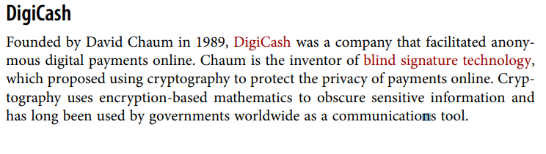

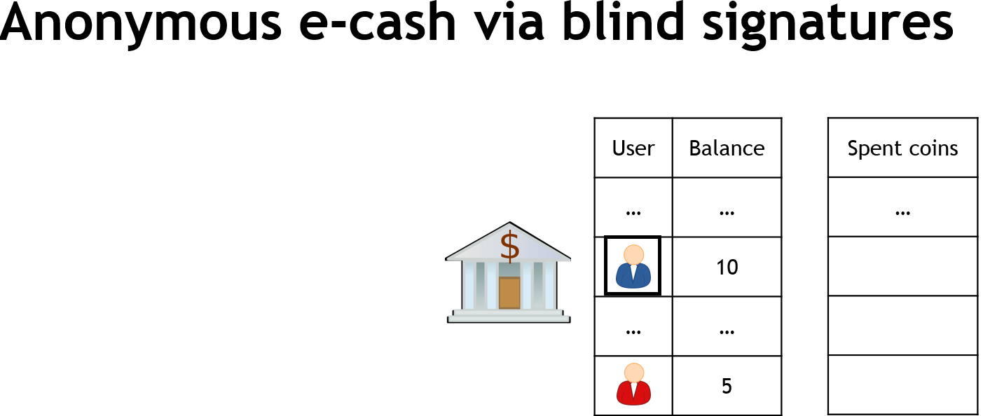

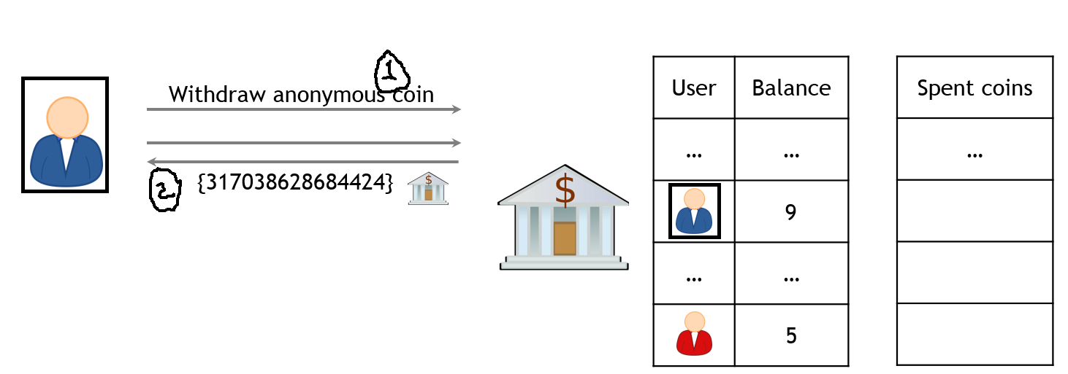

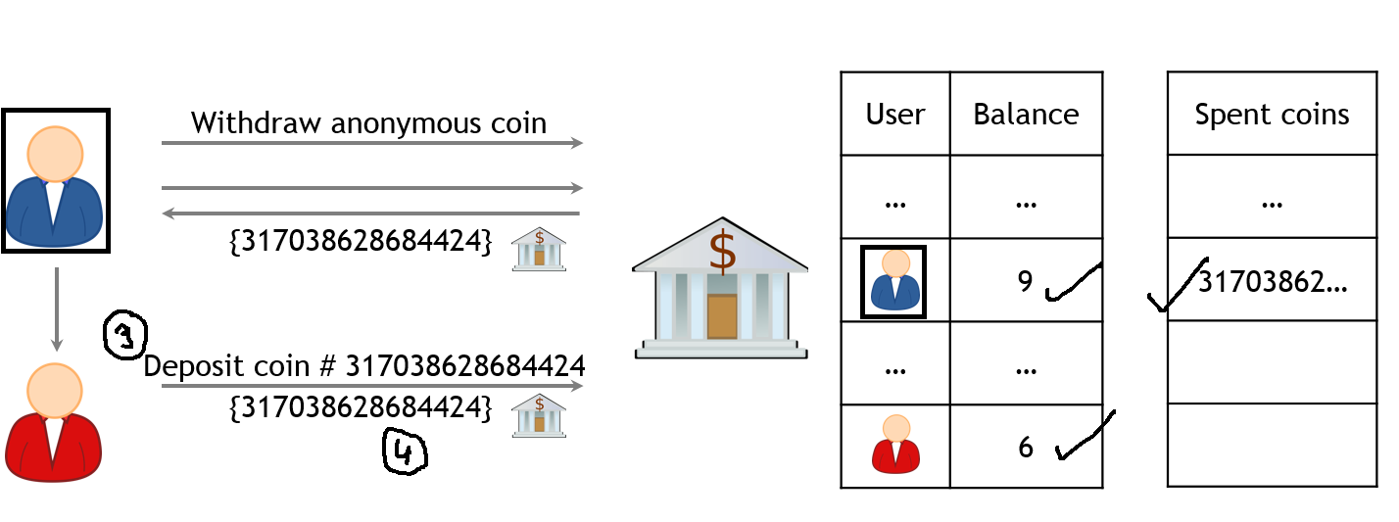

**1.Your First task is create wallet for Green address having to two legitimate user**

**2.Build any basic authentication mechanism between wallet and the legitimate user**

**3.Implement the function of withdraw anonymous coin which return hash value**

**Withdraw function pseudocode**

**{**

* **One of the legitimate user withdraw his/her coin from green address wallet**
* **Green address wallet update the account information of that particular user and generate the hash values**

**}**

4**.Implement the function of Deposit coin**